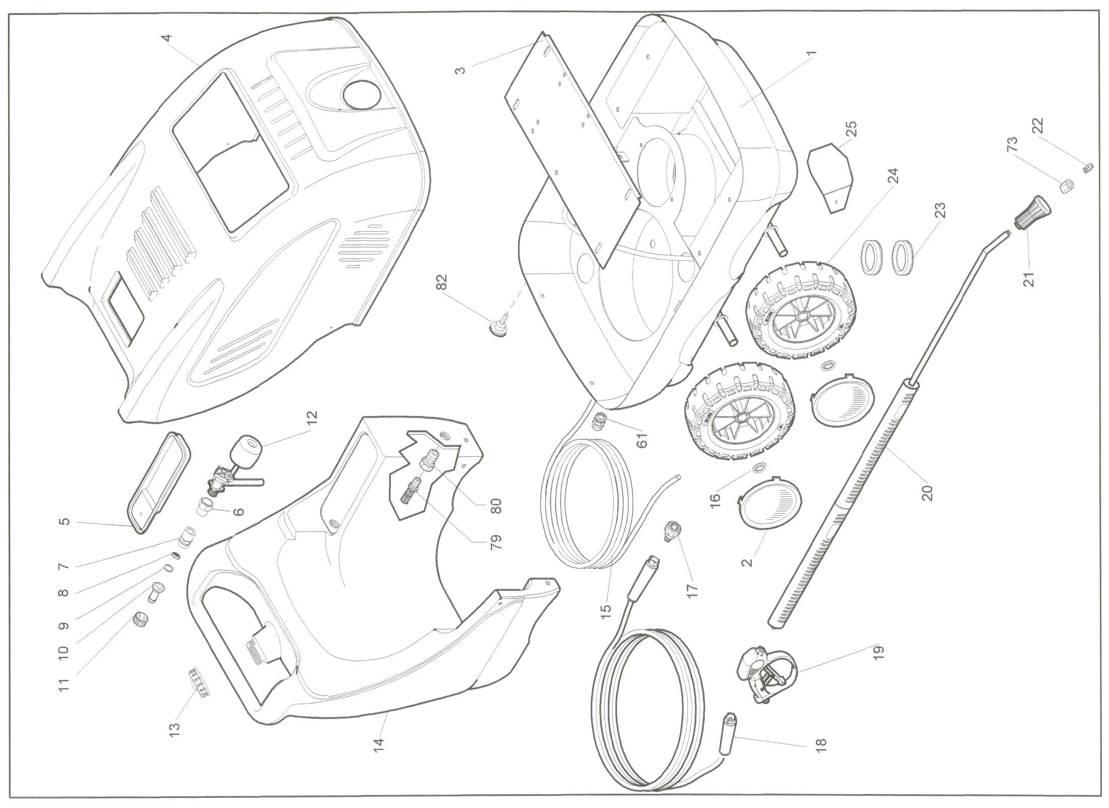

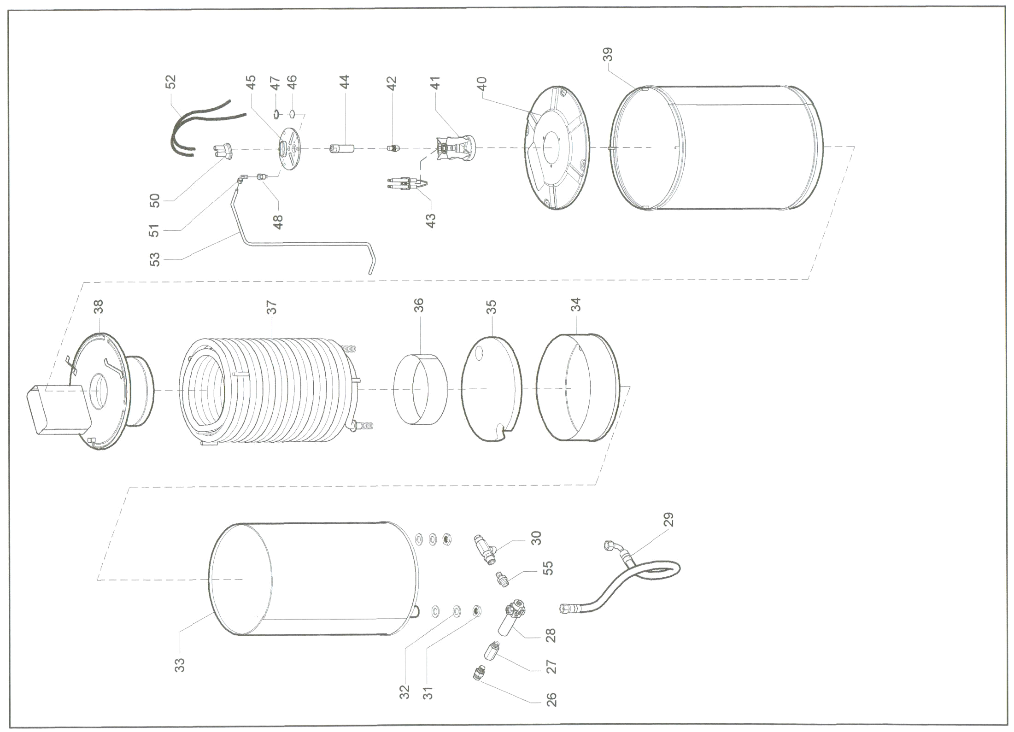

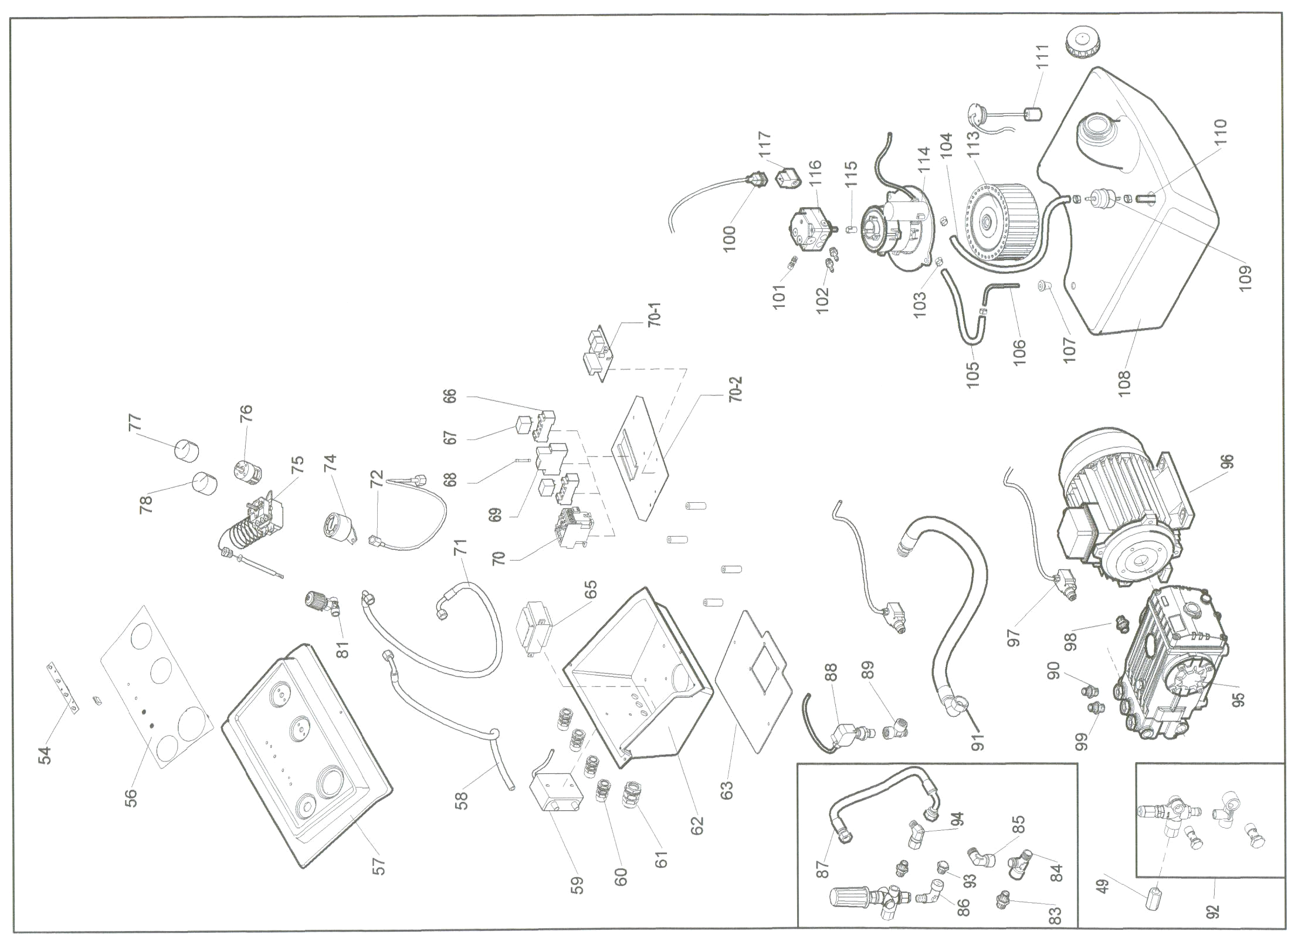

Pos. | Q.tà | Codice | ITALIANO | ENGLISH | FRANÇAIS | DEUTSCH | ESPAÑOL | Prezzo  €
1 | 1 | 311450001 | TELAIO BASE SUPERLUX VERNICIATO | SUPERLUX PAINTED BASE FRAME |  |  |  | 425,00
2 | 4 | 161450002 | BORCHIA GRIGIA PER RUOTA | GRAY WHEEL COVER |  |  |  | 6,00
3 | 1 | 311450006 | PIASTRA SUPPORTO MOTORE VERNICIATA | PAINTED PLATE FOR MOTOR SUPPORT |  |  |  | 42,00
4 | 1 | 141450001 | COFANO SUPERLUX ROSSO | SUPERLUX RED COVER |  |  |  | 245,00
4 | 1 | 141450005 | COFANO SUPERLUX GIALLO | SUPERLUX YELLOW COVER |  |  |  | 245,00
4 | 1 | 141450003 | COFANO SUPERLUX BLU | SUPERLUX BLU COVER |  |  |  | 245,00
4 | 1 | 141450004 | COFANO SUPERLUX GRIGIO | SUPERLUX GRAY COVER |  |  |  | 245,00
4 | 1 | 141450006 | COFANO SUPERLUX VERDE | SUPERLUX GREEN COVER |  |  |  | 245,00
5 | 1 | 141450002 | COPERCHIO VASCHETTA ACQUA | WATER TANK COVER |  |  |  | 8,20
6 | 1 | 111450019 | RACCORDO COLLEGAM.GALLEGGIANTE A SERBATOIO ¾” F-M | FITTING FOR CONNECTION OF FLOATING DEVICE TO TANK ¾” F-M |  |  |  | 20,50
7 | 1 | 111450020 | RACCORDO PORTA FILTRO D-D ¾”M-3/4”M | FITTING CARRYING FILTER D-D ¾”M-3/4”M |  |  |  | 20,50
8 | 1 | 111200013 | FILTRO ACQUA | WATER FILTER |  |  |  | 6,00
9 | 1 | 112200014 | GUARNIZIONE ACQUA | WATER GASKET |  |  |  | 5,42
10 | 1 | 112200007 | RACCORDO PORTA GOMMA D.17 | FITTING CARRYING RUBBER D.17 |  |  |  | 8,20
11 | 1 | 112200008 | GHIERA RACCORDO ENTRATA ACQUA | WATER INTAKE FITTING |  |  |  | 8,20
12 | 1 | 111450018 | GALLEGGIANTE ACQUA | WATER FLOATING DEVICE |  |  |  | 19,00

Pos. | Q.tà | Codice | ITALIANO | ENGLISH | FRANÇAIS | DEUTSCH | ESPAÑOL | Prezzo  €
13 | 2 | 131400001 | TAPPO SERBATOIO Ø60 | TANK CAP Ø60 |  |  |  | 6,20
14 | 1 | 131450001 | SERBATOIO DETERGENTE | DETERGENT TANK |  |  |  | 305,00
15 | 1 | 121450014 | CAVO ANTIFIAMMA 3X2,5 GRIGIO MONOFASE | GRAY SINGLE PHASE ANTI-FLAME HOSE 3X2,5 |  |  |  | 27,00
15 | 1 | 121450015 | CAVO ANTIFIAMMA 4X2,5 GRIGIO TRIFASE | GRAY THREE PHASE ANTI-FLAME HOSE 4X2,5 |  |  |  | 28,50
16 | 4 | 161100003 | ANELLO ELASTICO FERMA-RUOTA | ELASTIC RING FOR WHEEL STOP |  |  |  | 6,00
17 | 1 | 111250020 | ATTACCO RAPIDO LANCIA D-D 3/8”M – ½”F | LANCE QUICK COUPLING D-D 3/8”M – 1/2F |  |  |  | 25,00
18 | 1 | 111250021 | TUBO R1T 5/16 IDRO 10 MT FD 3/8”+FD3/8” + 2 MAN | HOSE R1T 5/16 IDRO 10 MT FD 3/8“+FD 3/8“ +2 MAN |  |  |  | 137,50
18 | 1 | 112200011 | TUBO R2T 5/16 IDRO 10 MT FD 3/8“+FD3/8“ +21 MAN | HOSE R2T 5/16 IDRO 10 MT FD 3/8“ + FD 3/8“ +2 MAN |  |  |  | 175,00
19 | 1 | 112200013 | IDROPISTOLA „AL19“ 3/8“M-1/4“F | „AL19“ GUN 3/8“M-1/4“F |  |  |  | 45,00
20 | 1 | 112200012 | LANCIA ATERMICA 1200mm | ATHERMIC LANCE 1200mm |  |  |  | 60,00
21 | 1 | 111100029 | PARAUGELLO IN GOMMA | RUBBER NOZZLE GUARD |  |  |  | 10,30
22 | 1 | 111150013 | UGELLO 0,35 15° (IDRO 120/10 W112) | NOZZLE 0,35 15° (MODEL 120/10 W112) |  |  |  | 13,00
22 | 1 | 112200005 | UGELLO 0,45 ¼ 15° (IDRO 120/10-W112 – 170/13 – 200/15) | NOZZLE 0,45 ¼ 15° (MODELS 120/10-W112 – 170/13 – 200/15) |  |  |  | 13,00
22 | 1 | 112200015 | UGELLO 0,50 ¼ 15° (IDRO 150/15) | NOZZLE 0,50 ¼ 15° (MODEL 150/15) |  |  |  | 13,00
22 | 1 | 111450024 | UGELLO 0,60 ¼ 25° (IDRO 150/21) | NOZZLE 0,60 ¼ 15° (MODEL 150/21) |  |  |  | 13,00
23 | 2 | 141400003 | PASSATUBO Ø70 | HOSE FAIR LEAD Ø70 |  |  |  | 7,00
24 | 4 | 161450001 | RUOTA VULCANIZZATA 260/80 | VULCANIZED WHEEL 260/80 |  |  |  | 4,00

Pos. | Q.tà | Codice | ITALIANO | ENGLISH | FRANÇAIS | DEUTSCH | ESPAÑOL | Prezzo  €
25 | 1 | 301250018 | PIASTRA PARZIALIZZATRICE ARIA VENTOLA | AIR FAN PARTIALIZING PLATE |  |  |  | 5,00
26 | 1 | 111250010 | RACCORDO INNESTO LANCIA D-D 3/8”M -1/2M | LANCE FITTING DEVICE D-D 3/8”M-1/2M |  |  |  | 8,20
27 | 1 | 111400010 | RACCORDO PROLUNGA D-D3/8”M 3/8”F L=40 | FITTING EXTENSION D-D 3/8”M 3/8”M L=40 |  |  |  | 14,50
28 | 1 | 111250012 | RACCORDO POZZETTO PORTA SONDA T 3/8”F-3/8”F-3/8”F-M 14X1 F | FITTING CARRYING FEELER T 3/8”F-3/8”F-3/8”F-M 14X1 F |  |  |  | 47,50
29 | 1 | 111450011 | TUBO R2T 3/8” L.730 FD 3/8” + F90° 3/8” | HOSE R2T 3/8“ L.730 FD 3/8“ + F90° 3/8“ |  |  |  | 25,00
30 | 1 | 111450009 | VALVOLA SICUREZZA MV 510 ¼“F | SAFETY VALVE NV 510 1/4F |  |  |  | 55,00
31 | 2 | 18110550 | DADO ESAGONALE 3/8“ | HEXAGONAL NUT 3/8“ |  |  |  | 7,00
32 | 2 | 181100410 | RONDELLA PIANA MEDIA M16 ISO 7089 | PLANE MEDIUM WASHER M16 ISO 7089 |  |  |  | 1,20
33 | 1 | 311450008 | CALDAIA INTERNA SERPENTINA 15 LT. | INSIDE BOILER 15 LT COIL |  |  |  | 204,00
34 | 1 | 301250015 | ANELLO CONTENIMENTO SERPENTINA | RING CONTAINING COIL |  |  |  | 85,00
35 | 1 | 141250001 | DISCO ISOLANTE Ø267X20 | ISOLATING DISK Ø267X20 |  |  |  | 16,00
36 | 1 | 311250006 | ANELLO CONTENIMENTO FIAMMA | RING CONTAINING FLAME |  |  |  | 25,00
37 | 1 | 111450001 | SERPENTINA 15 LT STANDARD | 15 LT STANDARD COIL |  |  |  | 275,00
38 | 1 | 311450009 | COPERCHIO INTERNO CALDAIA | INSIDE COILER COVER |  |  |  | 102,50
39 | 1 | 311450010 | CALDAIA ESTERNA SERPENTINA 15 LT | OUTSIDE BOILER 15 LT COIL |  |  |  | 290,00
40 | 1 | 301250027 | COPERCHIO ESTERNO CALDAIA | OUTSIDE BOILER COVER |  |  |  | 34,00

Pos. | Q.tà | Codice | ITALIANO | ENGLISH | FRANÇAIS | DEUTSCH | ESPAÑOL | Prezzo  €
41 | 1 | 301100019 | DEFLETTORE | DEFLECTOR |  |  |  | 43,00
42 | 1 | 111400011 | UGELLO GASOLIO B 60 Ø1,35 (IDRO 120/10) | FUEL NOZZLE B60 Ø1,35 (MODEL 120/10) |  |  |  | 35,19
42 | 1 | 111400014 | UGELLO GASOLIO B60 Ø1.50 (IDRO 170/13-150/15-200/15) | FUEL NOZZLE B60 Ø1.50 (MODEL 170/13-150/15-200-15) |  |  |  | 35,19
43 | 1 | 121250001 | CANDELETTA BIFILARE INOX | DOUBLE SPURCK PLUG IN STAINLESS STEEL |  |  |  | 35,00
44 | 1 | 301100021 | PORTAUGELLO | NOZZLE HOLDER |  |  |  | 10,00
45 | 1 | 141250002 | DISCO IN ALLUMINIO CHIUSURA CALDAIA | ALLUMINIUM DISK FOR BOILER CLOSE UP |  |  |  | 45,80
46 | 1 | 141250003 | VETRO CALDAIA Ø20X3,3 | BOILER GLASS Ø20X3,3 |  |  |  | 3,20
47 | 1 | 181250801 | ANELLO ELASTICO Ø22 | ELASTIC RING Ø22 |  |  |  | 2,00
48 | 1 | 111100020 | RACCORDO PROLUNGA D-D 1/8”M -1/8”F L.27,5 | EXTENSION FITTING D-D 1/8”M – 1/8”F L=27,5 |  |  |  | 8,20
49 | 1 | 112200002 | PROLUNGA ESAG. 3/8” (IDRO 120/10) | HEXAGONAL EXTENSION 3/8” (MODEL 120/10) |  |  |  | 10,50
50 | 1 | 121250002 | CAPPUCCIO DOPPIO | DOUBLE COVER |  |  |  | 6,50
51 | 1 | 111200004 | RACCORDO PM 90° 1/8”M Ø4 | FITTING PM 1/8”M Ø4 |  |  |  | 8,20
52 | 2 | 121350001 | CAVO ELETTRODI | ELECTRODES HOSE |  |  |  | 8,00
53 | 1 | 111450002 | TUBO GASOLIO IN RAME | COPPER FUEL HOSE |  |  |  | 23,00
54 | 1 | 121450009 | SCHEDA LED | LED CARD |  |  |  | 94,00
55 | 1 | 111450010 | RACCORDO 3/8M – 1/4M | FITTING 3/8M – 1/4M |  |  |  | 8,20

Pos. | Q.tà | Codice | ITALIANO | ENGLISH | FRANÇAIS | DEUTSCH | ESPAÑOL | Prezzo  €
56 | 1 | 151450003 | ADESIVO CRUSCOTTO | PANEL LABEL |  |  |  | 18,20
57 | 1 | 151450001 | COPERCHIO CRUSCOTTO SUPERLUX | SUPERLUX PANEL COVER |  |  |  | 65,00
58 | 1 | 111450014 | TUBO RETINMATO ¼” L.730 F90° ¼+ LIBERO | WIRED HOSE ¼ L.730 F90° ¼ |  |  |  | 14,00
59 | 1 | 121250004 | TRASFORMATORE P.220/240 S.2X12KV TC2LVCS | TRANSFORMER P.220/240 S.2X12KV TC2LVCS |  |  |  | 60,00
60 | 7 | 121100013 | PASSACAVO PG9 | HOSE FAIR LEAD PG9 |  |  |  | 3,80
61 | 2 | 121250005 | PASSACAVO PG 13.5 | HOSE FAIR LEAD PG 13.5 |  |  |  | 3,90
62 | 1 | 151450002 | BASE CRUSCOTTO SUPERLUX | SUPERLUX BASE PANEL |  |  |  | 48,00
63 | 1 | 301450012 | PIASTRA SUPPORTO CRUSCOTTO VERNICIATA | PAINTED PLATE FOR PANEL SUPPORT |  |  |  | 20,00
65 | 1 | 121450008 | TRASFORMATORE 220/380-24 | TYRANSFORMER 220/380-24 |  |  |  | 64,20
66 | 2 | 121450002 | ZOCCOLO MINI RELE’ 95.65 SMA | MINI RELAY DEVICE 95.65 SMA |  |  |  | 4,50
67 | 2 | 121450003 | MINI RELE’ FINDER 40.52 | MINI RELAY FINDER 40.25 |  |  |  | 10,24
68 | 1 | 121450005 | FUSIBILE 10X38 4A | FUSE 10X38 4A |  |  |  | 5,00
69 | 2 | 121450004 | PORTAFUSIBILE VCL 10X38 | FUSE HOLDER VCL 10X38 |  |  |  | 8,00
70 | 1 | 121450001 | CONTATTORE KNL 16 10-24 50/60HZ | CONTACTOR KNL 16 10-24 50/50HZ |  |  |  | 80,00
70-1 | 1 | 121450010 | SCHEDA DI CONTROLLO ARC 248 | CONTROL CARD ARC 248 |  |  |  | 136,00
70-2 | 1 | 301450018 | SUPPORTO IMPIANTO ELETTRICO | ELECTRIC PLANT SUPPORT |  |  |  | 14,00
71 | 1 | 111450013 | TUBO RETINATO ¼” L.730 F90° ¼”+F90° 1/4 | WIRED HOSE ¼” L.730 F90° ¼”+90° ¼” |  |  |  | 15,00

Pos. | Q.tà | Codice | ITALIANO | ENGLISH | FRANÇAIS | DEUTSCH | ESPAÑOL | Prezzo  €
72 | 1 | 111450033 | FLESSIBILE ALTA PRESSIONE PER MANOMETRO | HIGH PRESSURE FLEXIBLE FOR MANOMETER |  |  |  | 20,00
73 | 1 | 11110003 | RACCORDO PORTAUGELLO ¼” F-F | FITTING CARRYING NOZZLE ¼” F-F |  |  |  | 8,20
74 | 1 | 111450023 | MANOMETRO BAR 315 ¼” Ø50 | MANOMETER BAR 315 ¼” Ø50 |  |  |  | 28,00
75 | 1 | 121400003 | TERMOSTATO S/INTERRUTTORE TR/741 | THERMOSTAT WITHOUT SWITCH TR/741 |  |  |  | 52,50
76 | 1 | 121400006 | INTERRUTTORE COMMUTATORE 4G10-538-R | SWITCH 4G10-538-R |  |  |  | 36,00
77 | 1 | 121400005 | MANOPOLA Ø40 ABS ROSSO quadro | SQUARED RED ABS KNOB Ø40 |  |  |  | 13,75
78 | 1 | 121400004 | MANOPOLA Ø40 ABS ROSSO tondo | ROUND RED ABS KNOB Ø40 |  |  |  | 13,75
79 | 1 | 111450017 | FILTRO ACQUA 3/8” | WATER FILTER 3/8” |  |  |  | 30,00
80 | 1 | 111250011 | RACCORDO 3/8”F-3/4”M | FITTING 3/8”F-3/4”M |  |  |  | 20,50
81 | 1 | 111450022 | RUBINETTO DETERGENTE | DETERGENT TAB |  |  |  | 27,50
82 | 1 | 321450002 | VOLANTINO BLOCCA-RUOTA | WHEEL STOP DEVICE |  |  |  | 22,50
83 | 1 | 112200006 | RACCORDO PORTA FILTRO D-D3/4”M-1/2”M | FITTING CARRYING FILTER D-D ¾”M-1/2”M |  |  |  | 20,50
84 | 1 | 111450028 | RACCORDO T ½”M-1/2”M-1/2”F (IDRO 150/21) | T FITTING ½”M – ½”M – ½”F (IMODEL150/21) |  |  |  | 9,50
85 | 1 | 111450027 | RACCORDO 90° ½”M ½”F (IDRO150/21) | FITTING 90° ½”M – ½”F (MODEL 150/21) |  |  |  | 8,20
86 | 1 | 111450029 | RACCORDO 90° 3/8”M – 3/8”M (IDRO 150/21) | FITTING 90° 3/8”M-3/8”M (MODEL 150/21) |  |  |  | 9,15
87 | 1 | 111450026 | TUBO 13X23 L.500 FD ½”+F90° ½” (IDRO 150/21) | HOSE 13X23 L.500 FD ½”+F90° ½” (150/21) |  |  |  | 20,75

Pos. | Q.tà | Codice | ITALIANO | ENGLISH | FRANÇAIS | DEUTSCH | ESPAÑOL | Prezzo  €
88 | 2 | 111450007 | PRESSOSTATO 3/8” 15 BAR | PRESSURE SWITCH 3/8” 15BAR |  |  |  | 40,30
89 | 1 | 111150005 | RACCORDO T 3/8”M-3/8”F-3/8”F | T FITTING 3/8”M-3/8”F-3/8”F |  |  |  | 9,50
90 | 1 | 111450034 | RACCORDO 90° 1/8”M – ¼”F (IDRO 120/10) | FITTING 90° 1/8”M- ¼”F (MODEL 120/10) |  |  |  | 8,20
91 | 1 | 111450012 | TUBO 19X30 L.680 MD ¾”+F90° ¾” | HOSE 19X30 L.680 MD ¾”+F90° ¾” |  |  |  | 26,72
92 | 1 | 111450025 | VALVOLA VB35 COMPLETA (IDRO 120/10) | COMPLETE VALVE VB35 (MODEL 120/10) |  |  |  | 142,80
92 | 1 | 112200009 | VALVOLA VB55 COMPLETA (IDRO 170/13-150-15-200/15) | COMPLETE VALVE VB55 (MODEL 170/13-150/15-200/15) |  |  |  | 154,20
92 | 1 | 111450032 | VALVOLA VB9 COMPLETA (IDRO 150/21) | COMPLETE VALVE VB9 (MODEL 150/21) |  |  |  | 143,50
93 | 1 | 111450031 | RACCORDO 1/2M-3/8”F (IDRO 150/21) | FITTING ½”M-3/8”F (MODEL 150/21) |  |  |  | 8,20
94 | 1 | 111450030 | ADATTATORE 90° 3/8”M – 3/8”F GIREVOLE (IDRO 150/21) | TURNING ADAPTOR 90° 3/8”M-3/8”F (MODEL 150/21 |  |  |  | 9,80
95 | 1 | 082200001 | POMPA W112 (IDRO 120/10) | PUMP W112 (MODEL 120/10) |  |  |  | 512,00
95 | 1 | 082200002 | POMPA W130 (IDRO 120/10) | PUMP W130 (MODEL 120/10) |  |  |  | 215,00
95 | 1 | 082200006 | POMPA WS151 (IDRO 150/15) | PUMP WS151 (MODEL 150/15) |  |  |  | 654,00
95 | 1 | 082200004 | POMPA WS171 (IDRO 170/13) | PUMP WS171 (MODEL 170/13) |  |  |  | 670,00
95 | 1 | 082200003 | POMPA WS201 (IDRO 200/15) | PUMP WS201 (MODEL 200/15) |  |  |  | 766,00
95 | 1 | 082200005 | POMPA WS202 (IDRO 150/21) | PUMP WS202 (MODEL 10/21) |  |  |  | 798,00
95 | 1 | 081400001 | POMPA RK15.20 (IDRO 150/15-200/15) | PUMP RK15.20 (MODELS 150/15-200/15) |  |  |  | 680,00
Pos. | Q.tà | Codice | ITALIANO | ENGLISH | FRANÇAIS | DEUTSCH | ESPAÑOL | Prezzo  €
95 | 1 | 081500001 | POMPA RK21.20 (IDRO150/21) | PUMP RK21.20 (MODEL 150/21) |  |  |  | 710,00
96 | 1 | 092200001 | MOTORE 1F TGL 100 3HP/50 HZ (IDRO 120/10) | MOTOR 1F TGL 100 3HP/50HZ (MODEL 120/10) |  |  |  | 361,00
96 | 1 | 092200003 | MOTORE 3F TGL 100 5,5HP/50HZ | MOTOR 3F TGL 100 5,5HP/50HZ (IDRO 170/13-150/15) |  |  |  | 364,00
96 | 1 | 092200002 | MOTORE 3F TGL 112 7,5HP/50HZ (IDRO 200/15-150/21) | MOTOR 3F TGL 112 7,5HP/50HZ (MODEL 200/15-150/21) |  |  |  | 431,00
97 | 1 | 111450008 | PRESSOSTATO 3/8 40 BAR NERO | BLACK PRESSURE SWITCH 3/8” 40 BAR |  |  |  | 40,30
98 | 1 | 111450016 | RACCORDO D-D ½”M-1/4”M | FITTING D-D ½”M-1/4”M |  |  |  | 8,20
99 | 1 | 111450015 | RACCORDO D-D ¼”M-1/4”M (IDRO 150/21) | FITTING D-D ¼”M-1/4”M (MODEL 150/21) |  |  |  | 8,20
100 | 1 | 121200002 | CABLAGGIO POMPA GASOLIO | FUEL PUMP WIRING |  |  |  | 5,00
101 | 1 | 111200005 | RACCORDO PM D-D 1/8“M D.4 | FITTING PM D-D 1/85”M D.4 |  |  |  | 8,20
102 | 1 | 111200003 | RACCORDO PORTA GOMMA ¼”M D.7 | FITTING CARRYING RUBBER ¼”M D.7 |  |  |  | 8,20
103 | 1 | 181100801 | FASCETTA CLIP 11-13 | BAND 11-13 |  |  |  | 3,00
104 | 1 | 111450004 | TUBO GOMMA POST-FILTRO L.400 6X12 | RUBBER HOSE POST-FILTER L.400 6X12 |  |  |  | 6,00
105 | 1 | 111450005 | TUBO GOMMA SCARICO L.220 6X12 | DISCHARGE RUBBER HOSE L.220 6X12 |  |  |  | 4,50
106 | 1 | 061250002 | TUBO RAME SCARICO L.80/40 | DISCHARGE COPPER HOSE L.80/40 |  |  |  | 7,50
107 | 1 | 141250004 | PASSATUBO Ø6 | HOSE FAIR LEAD Ø6 |  |  |  | 4,00

Pos. | Q.tà | Codice | ITALIANO | ENGLISH | FRANÇAIS | DEUTSCH | ESPAÑOL | Prezzo  €
108 | 1 | 131450002 | SERBATOIO GASOLIO | FUEL TANK |  |  |  | 207,50
109 | 1 | 111250015 | FILTRO GASOLIO | FUEL FILTER |  |  |  | 6,00
110 | 1 | 111450003 | TUBO GOMMA PRE-FILTRO L.210 6X12 | RUBBER HOSE PRE-FILTER L.210 6X12 |  |  |  | 4,40
111 | 1 | 121400009 | SONDA LIVELLO GASOLIO | FUEL LEVEL DEVICE |  |  |  | 95,00
113 | 1 | 301350023 | VENTOLA ZINCATA 146X72 | ZINKED FAN 146X72 |  |  |  | 20,00
114 | 1 | 091450001 | MOTORE BRUCIATORE ZS9 220V 50HZ | MOTOR BURNER ZS9 220V 50HZ |  |  |  | 120,00
115 | 1 | 091200003 | GIUNTO POMPA GASOLIO | FUEL PUMP JOINT |  |  |  | 6,00
116 | 1 | 081450001 | POMPA GASOLIO SX | LEFT HAND FUEL PUMP |  |  |  | 81,60
117 | 1 | 081200002 | SOLENOIDE 24V | SOLENOID 24V |  |  |  | 21,00

